Algorithm a121 Microarchitecture Document

logo.png

Release Date: Apr 16, 2014

This document provides functional information for the a121 Algorithmic Memory® core.

Copyright 2012 (c) Memoir Systems. All rights reserved. No part of this document may be reproduced in any form or by any means, including electronic storage and retrieval, or translation into another language, without prior agreement and written consent from Memoir Systems, as governed by United States and international copyright laws.

Algorithm A121 Microarchitecture

|  |  |  |
| --- | --- | --- |
| Date | Reviewer | Comments |
| May 12 2014 | __ | Initial Release. |

Document Naming Convention

The naming strategy for the documentation is:

Microarchitecture_module#_function#_algo#_rev#

The field that doesn’t apply stays empty.

Microarchitecture_[core,algo,infra]_[1r2w,4r5ws, etc]_[a121,a32,etc]_[00,01,02,etc]

For example:

Microarchitecture_core_nr1rw__00

Is a core documentation with nr1w capability, revision 00.

Or

Microarchitecture_algo_4r5ws_a32_02

Is an algo documentation with 4r5ws capability, algo# a32, revision 02.

Or

Microarchitecture_infra_1r1w__00

|  |
| --- |
| Contents |

1. Functional Overview 1

2. Interface description 2

3. Algos.txt 3

4. Block level description 4

5. Key Parameters 5

6. Formal 6

7. Revision Change Log 7

# Functional Overview

The 1r1w_a121 IP provides 1R1W (2 port) functionality. It is built using bulk of single port memories (1RW) and a small amount of 2 port memoires (1R1W). Given the bulk of this IP is built on 1 port memories the area and power footprint of this IP is smaller than a traditional 2 port memory. The one port memory is mainly used to store the data. The two port memory stores the internal state needed by the IP logic.

This IP is implemented to reduce the read latency (Reduced Latency or RL). The target latency for this IP is gated by the latency of reading the data out from the T1 memory. The state lookup and all the relevant decisions are made in parallel and no additional cycle of latency is added on the read data path.

For more information, please refer to the documentation for core_1r1w_rl2, infra_laign_ecc_1r1w and infra_stack_1r1w.

# Interface description

The algo_top’s main interfaces include the clking ports; the read and write ports, which talk to the primary interface; the t1 ports which talk to the single port (T1) memories; and the t2 ports which talk to the 2 port (T2) memories.

|  |  |  |  |
| --- | --- | --- | --- |
| Pin | Pin Type | Description | Notes |
| Clock and Initialization | | | |
| clk | Input | Clock | Clock input pin |
| rst | Input | Reset | Reset pin |
| refresh | Input | Refresh | Signal to the controller that eDRAM can be refreshed in this cycle. Only needed when IP uses eDRAM. (Optional) |
| ready | Output | Ready | Assertion implies memory core ready for functional operation |
| Read Ports | | | |
| rd_adr | Input | Read Address | Address bits (width N bits) to denote up to 2N addresses;  N is parameter. Same value for all ports |
| read | Input | Read Valid | Denotes that a Read command is valid |
| rd_dout | Output | Read Data | Data (width W) associated with a read address;  W is parameter. Same value for all ports |
| rd_vld | Output | Read Data Valid | Denotes valid read data |
| rd_serr rd_derr | Output | Read Error | Denotes read data error. Data on *dout* pins is invalid |
| rd_padr | Output | Physical Address | Physical Address (width P bits) associated with the read. Parameter P depends on the physical address space of the memory core |
| Write Ports | | | |
| wr_adr | Input | Write Address | Address bits (width N bits). Parameter N is the same as that used for Read address. |
| write | Input | Write Valid | Denotes that a write command is valid |
| din | Input | Write Data | Data (width W bits) associated with a write command; Parameter W is same that for Read data. |
| **T1 Ports** | | | |
| t1_readA | Output | Read Valid | Denotes that the read command is valid for T1 memories |
| t1_writeA | Output | Write Valid | Denotes that the write command is valid for T1 memories |
| t1_addrA | Output | Address | Address bits (width N bits.) Address for both read and write command for the single port memory |
| t1_dinA | Output | Write data | Write data Input to T1 memories |
| t1_doutA | Input | Read data | Data associated with a read address; from T1 memories |
| **T2 Ports** | | | |
| t2_writeA | Output | Write Valid | Denotes that the write command is valid for the respective T2 memory. |
| t2_addrA | Output | Write Address | Address bits for write command |
| t2_dinA | Output | Write data | Write Data input to T2 memories |
| t2_readB | Output | Read valid | Denotes that the read command is valid for the respective T2 memory. |
| t2_addrB | Output | Read address | Address bits for read command |
| t2_doutB | Input | Read data | Data associated with a read address |

# Algos.txt

The memogen software uses this file to evaluate and estimate the best-fit memories for the given algo.

*# 1R1W_RL2*

*# Combined Tag and Cache. This algo is different from A21 interms of*

*#libs getting picked up in estimator. This algo will only use sram.*

*1R1W_A121(f, w, b) [RL]*

*vars : n __ bank_count(1)*

*ws __ words_array(n,w)*

*b' __ bits(b)*

*formulae : p = TAG_BITS(n)*

*w' = ws.max()*

*macros:*

*type1(BASE) : n * 1RW(f, ws, b')*

*type2 : 2 * 1R1W(f, w', b'+p)*

The above algorithmic description defines the characteristics (frequency, depth and width) of the memory macros used for 1r1w_a121. There are two types of memories in the IP that memogen software has to pick – type 1 (T1) and type2 (T2). The software uses the process information, user-defined parameters and the algorithmic description to decide which memories will best suit the requirements.

* **T1 Memory:** This memory is the bulk of the memory used in the 1r1w_a121 and is used for the primary data storage. The size of this memory is equal to total capacity requirement of the algorithmic memory. The depth of the memory is equal to the depth of required memory and the width is equal to the width of the IP. In 1r1w_a121 1RW (single port memory) is used as physical memory for T1 memory.
  + f – target frequency of T1 memory. This parameter is user defined.
  + n – is the optimal number of T1 macros or number of banks, in which the complete memory depth/capacity will be split. This parameter is optimized based on the physical library.
  + ws – The optimal depth of the T1 memory macros. For IP sizes which are non-power-of-two the tool can optimize the area using different size T1 macros. This parameter is optimized based on the physical library.
  + b’ – data width of the IP. This parameter is user defined.
* **T2 Memory:** This memory is used for two types of data – regular data that cannot be written in the T1 banks due to read and write collision, and the state data. The regular data is referred to as the cache data and the state data is referred to as the tag data. Reads are given higher priority on T1 reads. In case of a collision, write data is written to the T2 memory. The tag for 1r1w_a121 consists of the bank number and the write enable signals associated with the writes. Note that this structure is protected by ECC (SECDEC).
  + f – target frequency of T1 memory. This parameter is user defined.
  + w’ – The maximum depth of the T1 memory macros. For IP sizes which are non-power-of-two the tool can optimize the area using different size T1 macros. w’ would be the depth of the deepest t1 macro used. This parameter is optimized based on the physical library.
  + b’ – data with of the IP. This parameter is user defined.
  + p – is the width of the tag, the write enable and state info, ECC protected.

# Block level description

An algo_1r1w_rl2 _top instantiates:

1. a1_loop (algo) : This module consists of the two modules – core_1r1w_rl2 and mux. The core consists of the bulk of the algorithm and the mux translates the data from the logical p-interfaces and s-interfaces to physical T1 interfaces and T2 interfaces. The core flops the primary inputs depending on the FLOPIN parameter and dispatches read commands to both T1 and T2 memories. If a write was scheduled to the same T1 bank as a read then read gets the priority, and the write gets sent to the T2 memory, along with the state information, i.e. which bank the data belongs to, and the write enable.
2. For t1_loop (t1 memories): This module consists of ‘N’ instances of infra_align_ecc_1r1w where N is the total number of T1 banks. This module talks to the T1 memory.
3. For t2_loop (t2 state memories): Two instances of infra_align_ecc_1r1w and two instances of infra_stack_1r1w. Each instance controls the access to one of the two T2 memory macros or two banks. Cache and tag are combined together. One bank is for read cache and tag, other for write cache and tag.

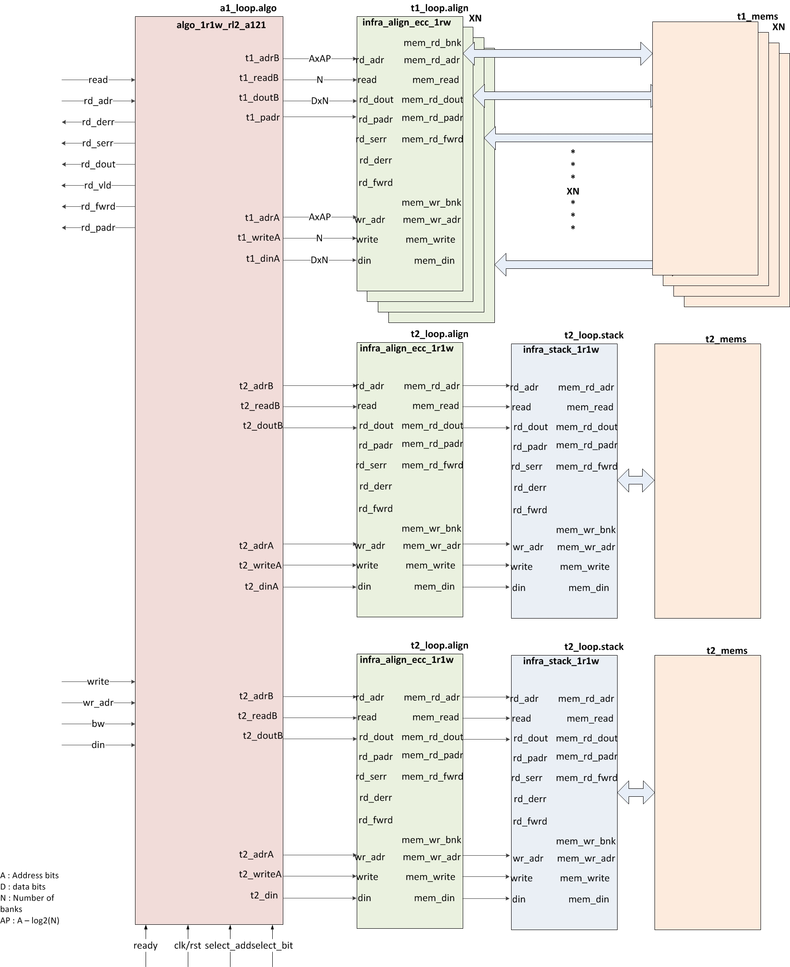

**Figure1: Block diagram for Algo_top**

# Key Parameters

The 1r1w_a121 algo uses the following key parameters:

|  |  |  |  |
| --- | --- | --- | --- |
| **Parameter** | **Description** | **Software Controlled** | **Hadware controlled** |
| WIDTH | Data width of the IP; It defines width of the data bus | <To be filled> | <To be filled> |
| NUMADDR | Depth of memory IP; Total address space for the IP |  |  |
| NUMVROW | Number of Virtual Rows; Number of rows in the T1 bank |  |  |
| NUMVBNK | Number of Virtual Banks; Number of T1 banks |  |  |
| BITPADR | Number of bits sufficient for all the banks in the design (T1 and T2 banks), used for physical address interface |  |  |
| NUMWRDS | Align Parameter |  |  |
| NUMSROW | Number of rows for select address; Select address is used for formal verification convergence |  |  |
| NUMWBNK | T2 packing parameter. Internally: T1 Number of banks per stack |  |  |
| SRAM_DELAY | Delay to access T1 banks |  |  |
| DRAM_DELAY | Delay to access T2 banks |  |  |
| FLOPIN | Controls the flopping option on input command signals. |  |  |
| FLOPOUT | Controls the flopping option on output signals. |  |  |
| FLOPCMD | Controls the option to flop the command to memory. |  |  |
| FLOPMEM | Controls the flopping option of data from memory. |  |  |
| ECCBITS | Controls the ECC bits in the state memory |  |  |

# Formal

The Cadence’s formal tool (ifv) is run using the frun.sh script which takes run_ifv as it’s input. It is run under run_sample/ifv/<cut> directory. It pulls tcl scripts from the tree and runs all the formal proofs. To run a specific proof, frun.sh can be run with –r <check> option. And to run in gui mode, a –gui option may be used.

Following are the primary design constraints and the assertions for the 1r1w_a121 algo:

**Assumptions:**

**Leaf nodes/assertions to prove:**

***assert_dout_check:*** *assert property (@(posedge clk) disable iff (rst) (read && (rd_adr == select_addr)) |-> ##(FLOPIN+DRAM_DELAY+FLOPOUT)*

*(rd_vld && ($past(fakememinv,FLOPIN+DRAM_DELAY+FLOPOUT) || (rd_dout[select_bit] == $past(fakemem,FLOPIN+DRAM_DELAY+FLOPOUT)))));*

* *Checks that the data on rd_dout bus is the same as what was stored on fakemem. The rd_vld and data are checked FLOPIN+DRAM_DELAY+FLOPOUT cycles after the read access.*

***assert_fwrd_check****: assert property (@(posedge clk) disable iff (rst) (read && (rd_adr == select_addr)) |-> ##(FLOPIN+DRAM_DELAY+FLOPOUT)*

*($past(fakememinv,FLOPIN+DRAM_DELAY+FLOPOUT) ||*

*$past(fakemem==mem_wire,FLOPIN+DRAM_DELAY+FLOPOUT) || rd_fwrd) &&*

*(rd_fwrd || !((rd_padr[BITPADR-1:BITPADR-BITPBNK] == NUMVBNK) ?*

*(FLOPOUT ? $past(t2_fwrdB_1_wire) : t2_fwrdB_1_wire) :*

*(FLOPOUT ? $past(t1_fwrdA_sel_wire) : t1_fwrdA_sel_wire))));*

* *Checks that if data going out on mem_wire doesn’t match with fakemem, then the rd_fwrd signal should be high. And then it checks that the forwarding is happening from the cache or t1 memories.*

***assert_padr_check****: assert property (@(posedge clk) disable iff (rst) (read && (rd_adr == select_addr)) |-> ##(FLOPIN+DRAM_DELAY+FLOPOUT)*

*((rd_padr == {NUMVBNK,(FLOPOUT ? $past(t2_padrB_1_wire) : t2_padrB_1_wire)}) ||*

*(rd_padr == {select_bank,(FLOPOUT ? $past(t1_padrA_sel_wire) : t1_padrA_sel_wire)})));*

* *Checks that the value of padr matches the physical bank value; either t1 bank address or cache.*

***assert_derr_check****: assert property (@(posedge clk) disable iff (rst) (read && (rd_adr == select_addr)) |-> ##(FLOPIN+DRAM_DELAY+FLOPOUT)*

*($past(fakememinv,FLOPIN+DRAM_DELAY+FLOPOUT) ||*

*((rd_padr[BITPADR-1:BITPADR-BITPBNK] == NUMVBNK) ?*

*(rd_serr == (FLOPOUT ? $past(t2_serrB_1_wire) : t2_serrB_1_wire)) &&*

*(rd_derr == (FLOPOUT ? $past(t2_derrB_1_wire) : t2_derrB_1_wire)) :*

*(rd_serr == (FLOPOUT ? $past(t1_serrA_sel_wire) : t1_serrA_sel_wire)) &&*

*(rd_derr == (FLOPOUT ? $past(t1_derrA_sel_wire) : t1_derrA_sel_wire)))));*

* *Checks all possible combinations of derr and serr.*

**Memoir ip**

FAKEMEM

FAKEMEM

FAKEMEM

FAKEMEM

FAKEMEM

FAKEMEM

FAKEMEM

FAKEMEM

1RW SRAM

1R1W SRAM

Logic Cone

1R1W SRAM

Logic Cone

Logic Cone

Read Data Bus (dout)

dout check

FAKEMEM

Golden Reference Model

Assertion

Write path

Read path

Write Data Bus

The diagram above shows the logical view of how the IP is verified formally. The complete IP is sliced into several logic cones. Each cone has a corresponding golden memory model (fakemem). When a write request is launched at the input of any logic cone, it gets captured in the golden memory. On a read, we compare the read data returned by the logic cone with golden memory. The read check happens on the interface of the cone of logic. This check is captured in the form of an SVA assertion or a property. Formal verification when run, will try to prove or break these assertions. The assertions cover the complete code, including the logic inside each cone and all the interfaces between the cones.

The diagram below zooms into one of the logical cones. It shows a simplified golden memory model and a simplified code for a read dout assertion. The formal tool exhaustively toggles all the (primary) input pins, complying with the constraints, to try and break the assertions.

rd_dout

rd_addr, read

wr_adr, bw, din

Logic cone 1

FAKEMEM

dout check assertion

for logic cone 1

Golden Memory for

Logic cone 1

Logic cone 2

FAKEMEM

Golden Memory for

Logic cone 2

***assert rd_dout_check: assert property (@(posedge clk) disable iff (rst) (read && (rd_adr == select_addr)) |-> ##(MEM_DEL) (fakememinv || (rd_dout[select_bit] == fakemem)));***

***reg fakememinv;  
reg fakemem;  
always @(posedge clk)  
  if (rst)  
    fakememinv <= 1'b1;  
  else if (write && (wr_adr == select_addr) ) begin  
    fakememinv <= 1'b0;  
    fakemem <= din[select_bit];  
  end***

To evaluate the formal coverage of the design, we have a post processing flow developed inhouse. The fchkr.sh script retrieves all the checks in the design. Then it parses all the logfiles to make sure that all the assertions are (formally) proven to give us a 100% coverage of our design. It prints out the constraints, asssertions and proven assertion for each run.

Several design for verification techniques have been used to guarantee that formal tool is able to converge proofs completely on the IPs. The simple semantic of memory IPs (i.e. read data to an address should be the last data written to that address) have also been a key in the formal results we achieve for the IP. The goal of the techniques mentioned above is to reduce the state space both temporally and spacially. We use these to help the formal tool converge the properties exhaustively.

# Dynamic Simulation

The dynamic simulations are run for the following scenarios:

1. Reset checks
2. Boundary and capacity checks
3. Checking that the assumptions of formal.

A dynamic simulation testbench gets automatically generated with the cut. A dynamic simulation can be run by simply going to run_sample/ directory and running the ./run script.

# Revision Change Log

|  |  |  |
| --- | --- | --- |
| Version | Date of Release | Notes |
| V1.0 | Apr 16 2014 | Initial Release. |

**Memoir Systems Inc.**

**2350 Mission College Blvd. # 1275, Santa Clara, CA 95054**

**Phone: 1-408-550-2382**

**Email: support@memoir-systems.com**